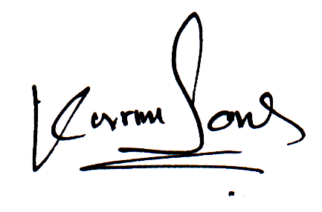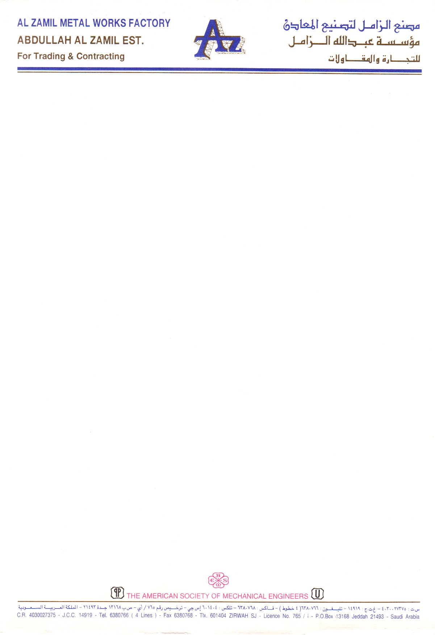

TO WHOM IT MAY CONCERN

This is to certify that Mr. <Name> s/o <fname>, Pakistani National, Passport No. <Passport> has been worked here at Al-Zamil Metal Works Factory as a <Designation> from <From2> to <To2>.

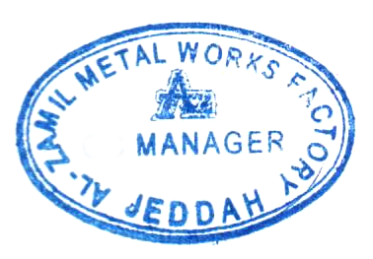

ABDULLAH I. AL ZAMIL

General Manager

Al-Zamil Metal Works Factory

JEDDAH